**Notes on sampling strategy for the collection of ground-dwelling arthropod fauna (EcoStack agro-ecosystem photo-inventory project)**

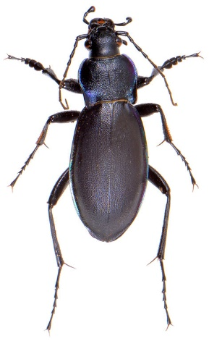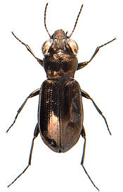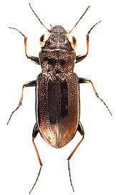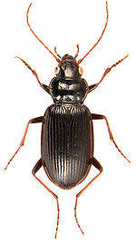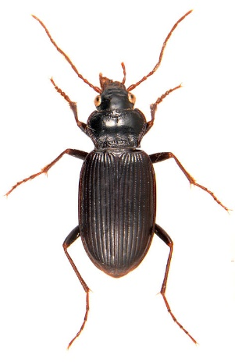INSECTA: COLEOPTERA  
Carabidae – major genera: *Carabus*, *Bembidion*, *Pterostichus*, *Amara*, *Harpalus*, *Agonum\** (the latter* are mainly found in very damp habitats, not personally observed any spp. at RRes) – *C. violaceus* are only very occasional in traps; several *Bembidion* should be present (e.g. *B. lampros, obtusans* and others); *P. madidus, melanarius, niger* and possibly others like *strenuus*, inc. *Abax parallelipipedus* etc.; *H*. *affinis, rufipes* etc.; also abundant/frequent/occasional on RRes farm sites are *Anchomenus dorsalis*, *Poecilus cupreus/versicolor*, *Nebria brevicollis/salina*, *Notiophilus* (*biguttatus*, maybe other spp.)*, Trechus* (*quadristriatus*, maybe other spp.)*, Asaphidion, Acupalpus*, *Loricera pilicornis, Demetrias* (*atricapillus*, maybe other spp.), *Clivina* (probably *C. fossor*, “mostly subterranean though may be found on open areas of soil at night” [ukbeetles.co.uk])   
- Ground-living ± running/subterranean species – “active, terrestrial beetles which forage on the ground surface and shelter in litter and under stones, logs etc.” (Luff, 2007)  
- “Nocturnal except where stated…species are black, brown or reddish (e.g. all *Pterostichus*) ”; “diurnal species tend to be strongly metallic (e.g. *Agonum*, many *Amara, B. lampros/properans*), and large-eyed (*Asaphidion*, *Notiophilus*…etc.)” (Duff, 2012)   
- *Bembidion = “*both diurnal and nocturnal species represented”; often run in sunshine (Luff, 2007)  
- “Many species occur in a rather limited range of moisture conditions (…xerophilous species such as most *Harpalus*)” – generally stenotropic taxa, though some are relatively eurytopic (Luff, 2007)  
- “In farmland so-called ‘beetle banks’ are designed to encourage predatory arthropods, especially ground beetles, to become established so that they may prey upon undesirable agricultural pests (Macleod *et al*., 2004)” (Duff, 2012)

*Carabus violaceus* ssp. *solicitans*

*Notiophilus aquaticus*

*Notiophilus biguttatus*

*Nebria brevicollis*

*Nebria salina*

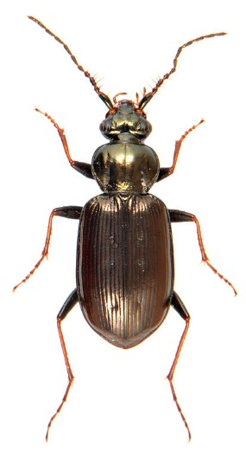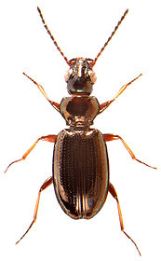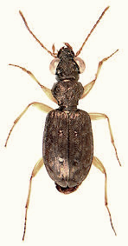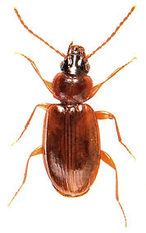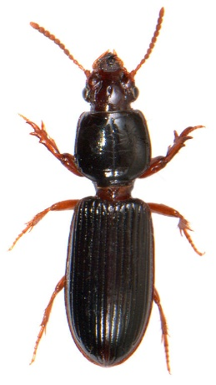

*Bembidion lampros*

*Asaphidion curtum*

*Trechus quadristriatus*

*Clivina fossor*

*Loricera pilicornis*

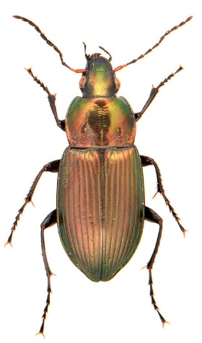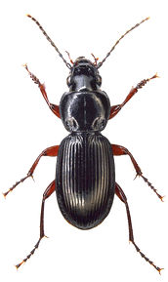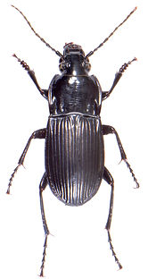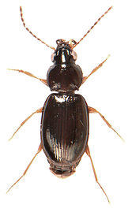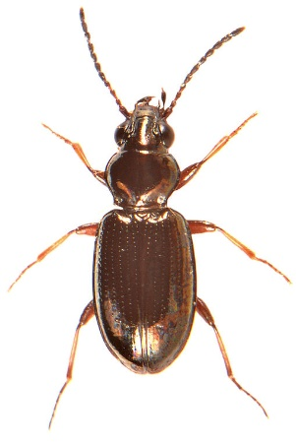

*Pterostichus madidus*

*Poecilus cupreus*

*Abax parallelepipedus*

*Bembidion obtusum*

*Bembidion properans*

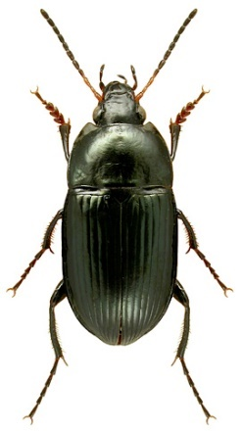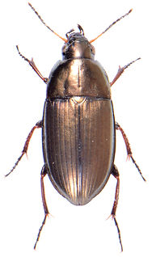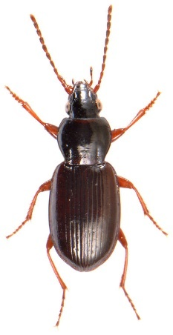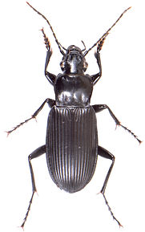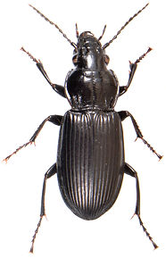

*Amara ovata*

*Amara aenea*

*Pterostichus strenuus*

*Pterostichus niger*

*Pterostichus melanarius*

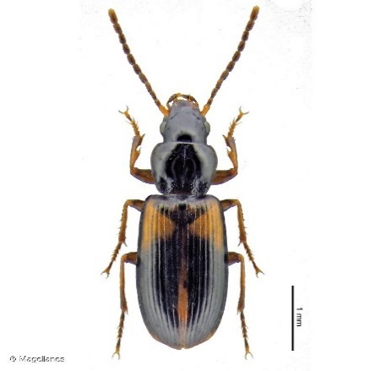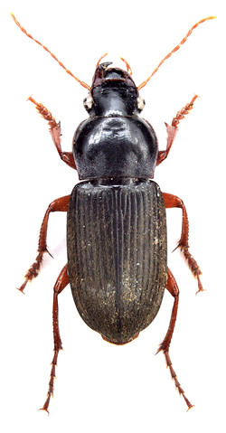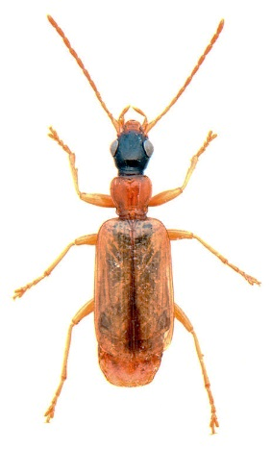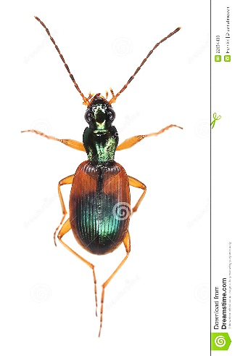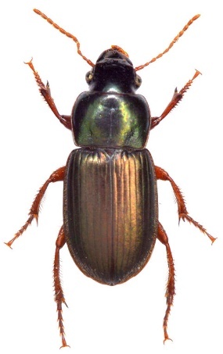

*Acupalpus meridianus*

*Anchomenus dorsalis*

*Demetrias atricapilus*

*Harpalus rufipes*

*Harpalus affinis*

Staphylinidae – some genera observed at RRes: *Tachyporus*, *Tachinus*,(=Tachyporinae) *Omalium*, (=Omaliinae) *Anotylus,* (=Oxytelinae) *Ocypus*, *Philonthus*, *Xantholinus*, (=Staphylininae) *Stenus* (Steninae);and *potentially* ‘sister’ genera of those aforementioned (unconfirmed) e.g. *Tasgius*, *Quedius*, *Bisnius*, *Gabrius, Othius*, *Gyrohypnus* (=Staphylininae) etc., including abundant aleocharines (on Aleocharinae: “adults can be swept, beaten or sieved from many situations, many are nocturnal, some come to light, they occur in pitfall traps and some are occasionally numerous in yellow-pan traps” [ukbeetles.co.uk] – some genera encountered previously include *Aleochara*, *Cypha*, *Ilyobates*, *Plataraea* etc., and numerous tribes, such as Athetini, Homalotini and Oxypodini, are likely present)  
- Ground-living ± running/subterranean species, like carabids – the “elongate, flexible bodies of Staphylinidae allows them to weave through soil crevices, litter and tangled vegetation” (Lott, 2009, 2011)  
- “Staphylinidae can be collected using similar methods to those that are effective for Carabidae. Pitfall trapping, looking under stones, dissecting grass tussocks and sieving litter are invariably successful in finding large numbers…species with specialist habitats can be found under bark and in rotten wood, fungal fruiting bodies, shingle banks, dung, carrion, underground mammal or bird nests, ant nests…” (Lott, 2009, 2011)  
- “Sweeping vegetation, especially grassland, will always produce staphs, more especially Tachyporinae, Omaliinae, Aleocharinae and Oxytelinae, and some of these will be found in abundance on flowerheads…decaying leaf-litter, especially on woodland margins, among grass tussocks and in marginal situations can be rich in species…decaying wood and debris collected from under bark can also produce a wide diversity of species… searching tree-trunks and fungi at night will produce many active specimens and a few are even associated with terrestrial molluscs (e.g. *Ocypus olens*)” [ukbeetles.co.uk])  
- *Stenus* = diurnal (large eyes), predatory (“some have particular preferences such as fine sand or gravelly substrate, or open rather than densely vegetated habitats”); Staphylininae = “most are nocturnally active, resting by day under debris etc.” [ukbeetles.co.uk]  
- *Phyllodrepa* spp. (Omaliinae) “may be found in piles of bird droppings and are typically associated with feral pigeons” [ukbeetles.co.uk] (= could be worth searching for pigeon droppings in Great Field)  
- *Anotylus* spp. (Oxytelinae)…”the majority are to be found in dung and rotting vegetation” [ukbeetles.co.uk] (= could be worth checking decaying and fallen OSR litter in Great Field)

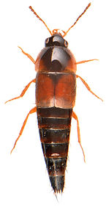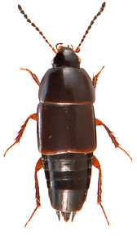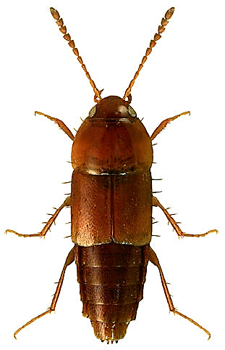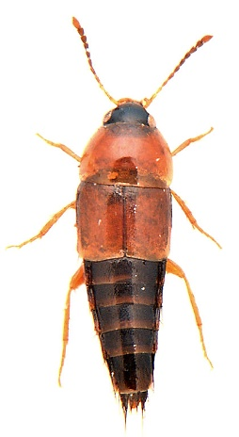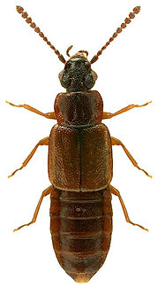NB: *Quedius* spp. *will* eat other staphylinids (Bear this in mind if keeping staphs together!)

*Tachinus*

*Omalium*

*T. nitidulus*

*T. chrysomelinus*

*Tachyporus hypnorum*

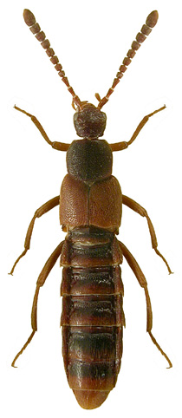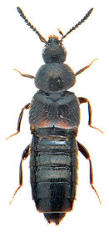

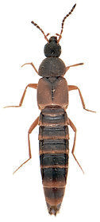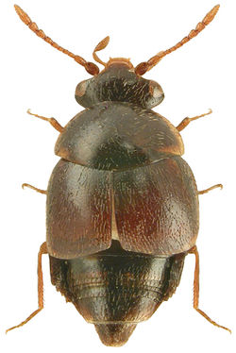

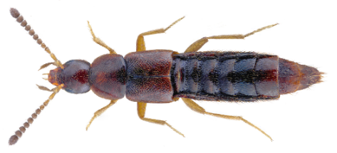

*Aleochara*

*Cypha longicornis*

*Cousya*

*Ilyobates*

*Oxypoda*

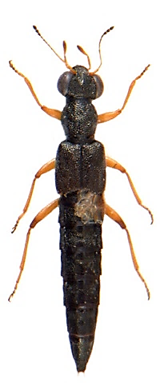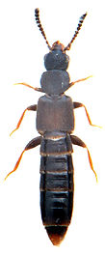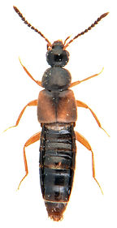

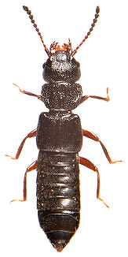

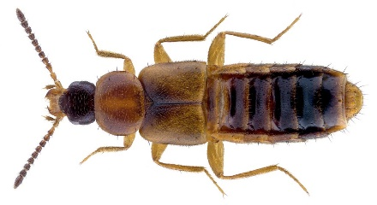

*Stenus*

*Anotylus*

*Homalota*

*Atheta*

*Plataraea*

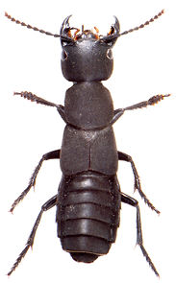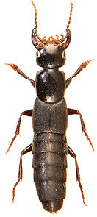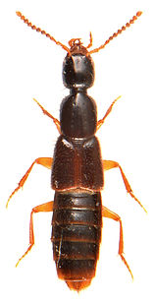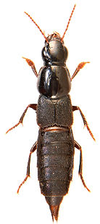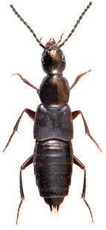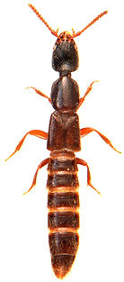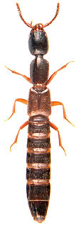

*Tasgius*

*Ocypus*

*Gabrius*

*Quedius*

*Philonthus*

*Gyrohypnus*

*Xantholinus*

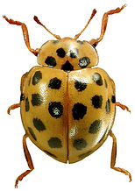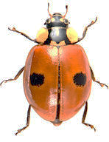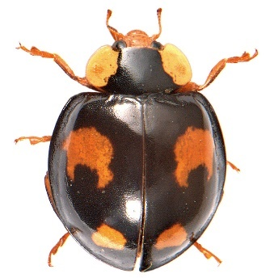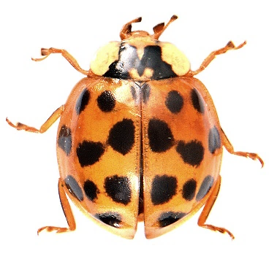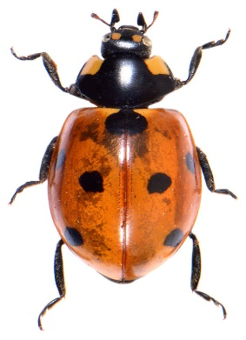Coccinellidae – species most commonly encountered on RRes farm sites include: *Coccinella septempunctata* (7-spot ladybird), *C. bipunctata* (2-spot ladybird), *Harmonia axyridis* (f. *succinea*, *spectabilis*, *conspicua*) (Harlequin ladybird) and *Psyllobora vigintiduopunctata* (22-spot ladybird)

*Psyllobora* 22-*punctata*

*H. axyridis* f. *spectabilis*

*Harmonia axyridis* f. *succinea*

*Adalia bipunctata*

*Coccinella 7-punctata*

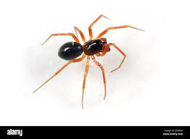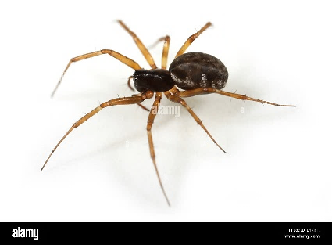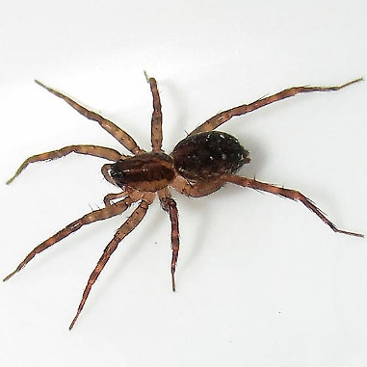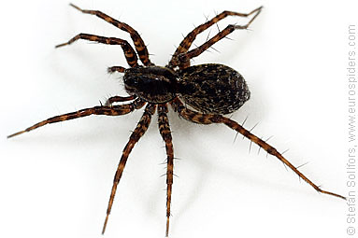  
  
ARACHNIDA: ARANEAE  
- Abundant in ecosystems and exclusively carnivorous – among British families there are ground-running and ‘sit-and-wait’ species, and those most active during the day and the night  
- Families most commonly encountered on RRes farm sites include: Lycosidae, Linyphiidae, Tetragnathidae, Theridiidae and Thomisidae; and to a lesser extent: Clubionidae, Gnaphosidae, Salticidae and Zoridae  
- Pitfall traps are recommended to effectively sample large numbers of ground-running and/or night-active species (e.g. lycosids, clubionids, gnaphosids) particularly in the summer months (Jones-Walters, 1989)  
- Identifiable taxa previously caught this way include: *Clubiona*, *Enoplognatha thoracica*, *Euophrys frontalis*, *Pachygnatha clercki/degeeri*, *Pardosa*, *Pirata*, *Xysticus cristatus,* and *Zora spinimana*  
- Hand-searching and pootering are preferential selective methods when only seeking *some* rather than any and all specimens; a strong hand- or head torch can render night searches profitable (the eyes of members of the Lycosidae reflect light making them easy to pinpoint)  
- Live spiders kept in the same tube or storing receptacle will eventually eat or damage each other (gnaphosids predominantly feed on other spiders!)

*Pardosa*

Linyphiidae

Linyphiidae

*Pirata*

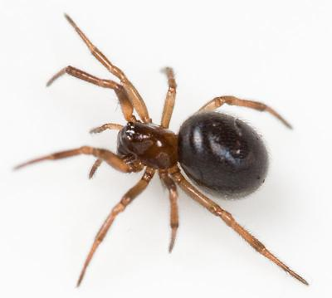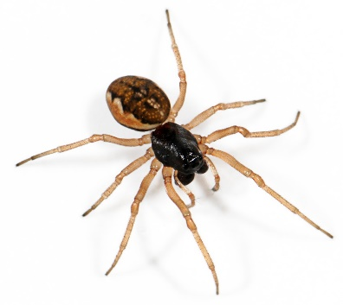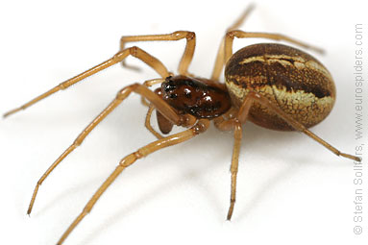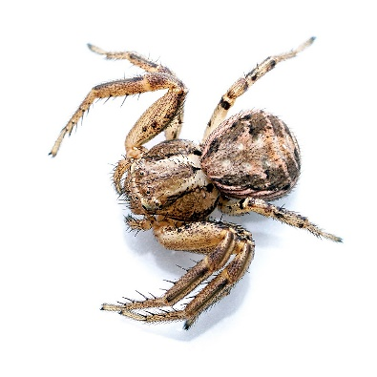

*Enoplognatha thoracica*

*Pachygnatha clercki*

*Pachygnatha degeeri*

*Xysticus cristatus*

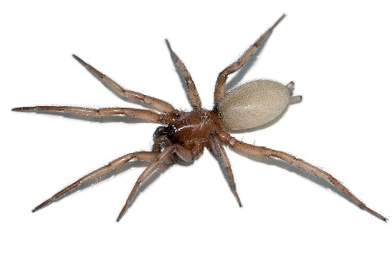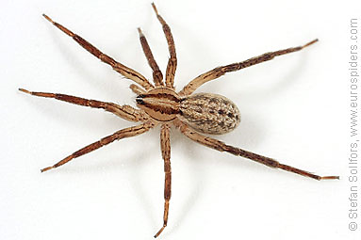

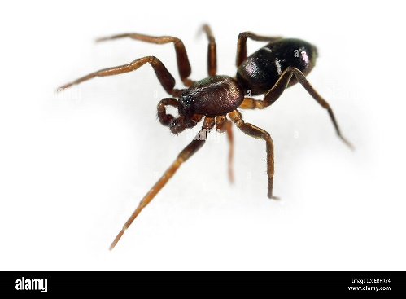

Gnaphosidae

Gnaphosidae

*Zora spinimana*